If you are using a chromebook to access a student’s google drive make sure that you use the student’s school email address to log into the chromebook before attempting to look for their school google drive.

To access student google drives at home on a desktop or laptop computer, follow these steps

- Download and then launch google chrome on your device (an app for google drive is available in the app store for Apple devices) and then go to google.com.
- Click on the blue sign in button in the upper right corner of the page or click to add another account
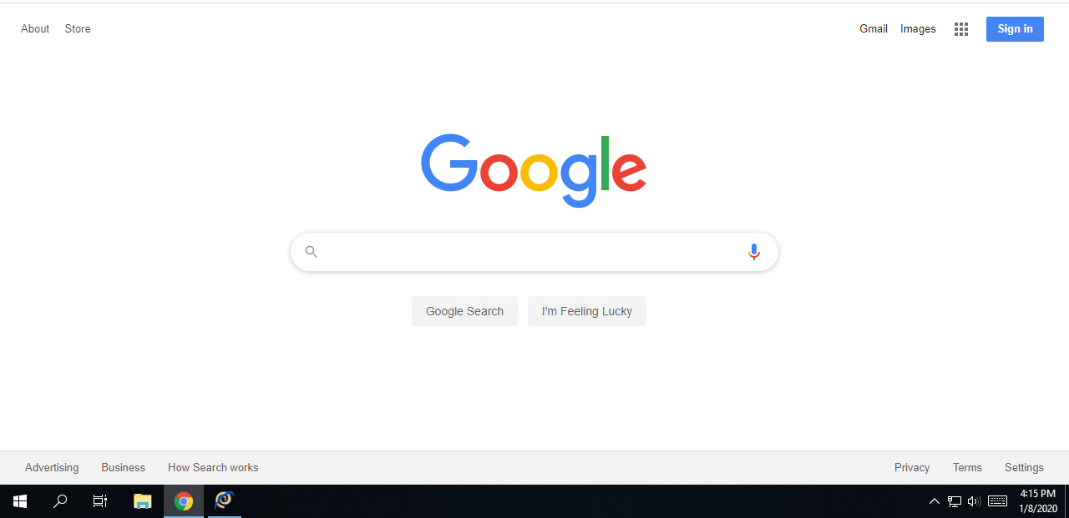
- Google will ask you for your email address to sign into the google account.
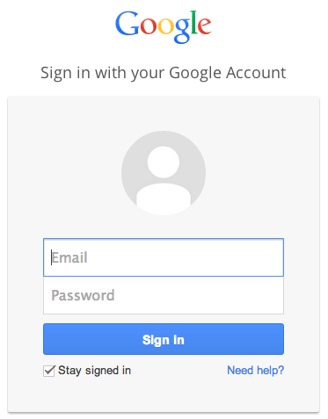or
The google drive email address for student google accounts is their username which they use to log into all school chromebooks followed by @prescott.k12.wi.us. Their password is a combination of letters and numbers. Please contact their teacher if they do not remember this information.

